ASSIGNMENT 1

Q1. The prices of five bikes in a shop are: ₹12,000, ₹15,000, ₹18,000, ₹20,000, ₹50,000
- What is the mean price of a bike? (2 Marks)
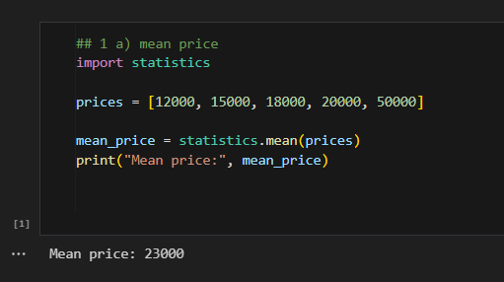
- What is the median price of a bike? (2 Marks)
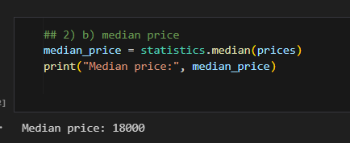
- If the shop owner wants to make the bikes seem affordable, which "average" (mean or median) should they advertise?Why?
Ans:
The shop owner should advertise the Median (₹18,000).
Why: The median is significantly lower than the mean (₹23,000). The mean is heavily influenced by the single high-priced outlier (₹50,000), which skews the average upwards. The median better represents the typical, more affordable price of the bikes in the shop.

Q2. Describe the relationship between a histogram's shape and the values of its mean, median, and mode in a left-skewed distribution.
Ans:
In a left-skewed distribution (also called negatively skewed), the tail of the histogram stretches to the left (towards smaller values).
Here’s the relationship between mean, median, and mode:
Mode → The highest point (peak) of the distribution, located toward the right (since most data are larger values).
Median → Lies to the left of the mode but still closer to the center of the data.
Mean → Pulled further left by the long tail of small values, so it is the smallest of the three.
-> Order in a left-skewed distribution:
Mean < Median < Mode
Summary: In a left-skewed histogram, the mean is less than the median, which is less than the mode because the long-left tail drags the mean downward.
Would you like me to also make a small diagram (using code to plot a left-skewed distribution) to visualize this relationship?

Q3. The following data represents the exam scores (out of 100) for 10 students:
85, 92, 78, 90, 85, 67, 88, 95, 85, 72
(a) Calculate the mean, median, and mode for this data.

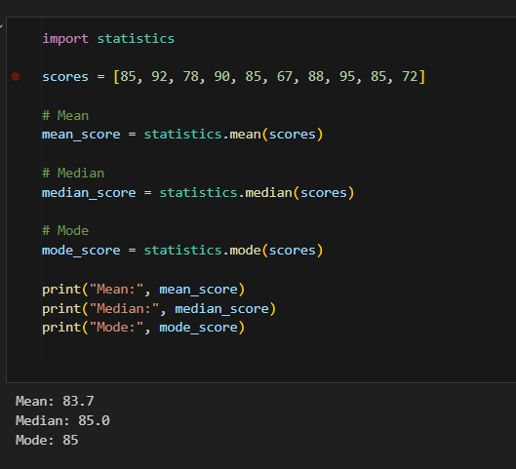
(b) Based on your values from part (a), describe the shape of the distribution
(symmetrical, skewed left, or skewed right). Justify your answer.
Ans:
Shape of the distribution
Mean (83.7) < Median (85) ≈ Mode (85)
Since the mean is slightly less than the median/mode, there is a slight left skew, but because the difference is very small, the distribution is almost symmetrical.
Answer: The distribution is approximately symmetrical, because mean, median, and mode are very close.

(c) Find the Five-Number Summary for this data.
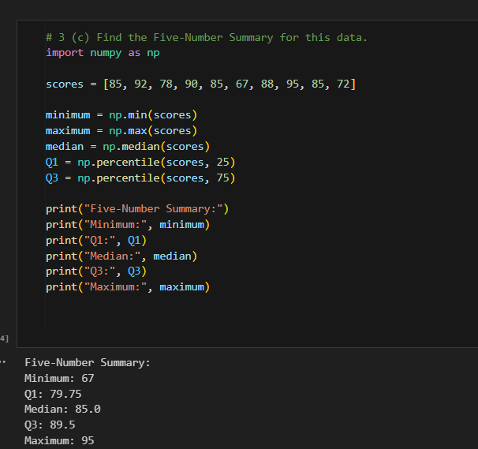

Q4. Differentiate between a population parameter and a sample statistic with an example of each.
Aspect | Population Parameter | Sample Statistic
Definition | A numerical value that describes a whole population. | A numerical value calculated from a sample of the population.
Symbol Example | Mean: μ, Standard Deviation: σ | Mean: (\bar{x}), Standard Deviation: s
Purpose | Describes true characteristics of the entire population. | Estimates the population parameter.
Example | Suppose a company has all 1,000 employee salaries: the mean salary of $55,000 is a population parameter. | If you randomly select 10 employees and calculate their mean salary of $53,000, that is a sample statistic.

Q5. A small company has 5 employees with the following annual salaries:
$45,000, $50,000, $55,000, $60,000, $250,000
(a) Calculate the mean and median salary.
Ans:
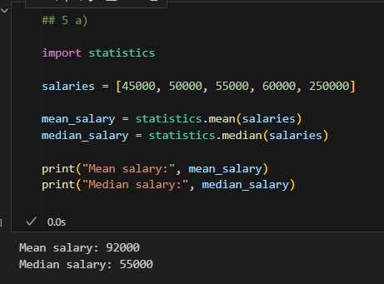
(b) The company wants to attract new hires by advertising the "average" salary. Which measure would they likely use? Which measure would a potential employee prefer to see? Explain the reason for the difference.

Company: Likely to advertise the mean = $92,000, because it looks higher due to the extremely high salary ($250,000) pulling the mean upward.
Potential Employee: Would prefer to see the median = $55,000, because it represents the typical salary more accurately, ignoring the outlier.
Reason for difference:
Mean is sensitive to extreme values (outliers).
Median is resistant to outliers and gives a better idea of what most employees earn.

Q.6 The following data represents the exam scores (out of 100) for 10 students:
85, 92, 78, 90, 85, 67, 88, 95, 85, 72
(a) Calculate the mean, median, and mode for this data.
Ans:
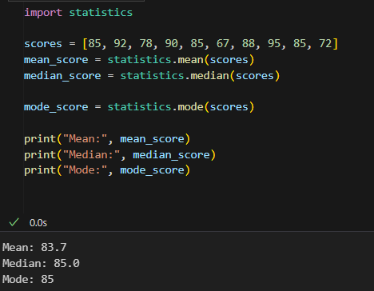

(b) Based on your values from part (a), describe the shape of the distribution (symmetrical, skewed left, or skewed right). Justify your answer.
Ans:
(b) Shape of the distribution
Mean (83.7) < Median (85) ≈ Mode (85)
Because the mean is slightly less than median/mode, the distribution is slightly left-skewed, but the difference is very small.
Conclusion: The distribution is approximately symmetrical.
(symmetrical, skewed left, or skewed right). Justify your answer.
(c) Find the Five-Number Summary for this data
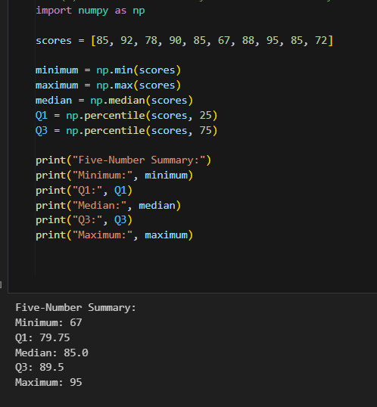
Q7. Graphical Representation
A quick survey of 20 students about their preferred mode of learning yielded the following data:
(H: Hybrid, O: Online, F: In-Person/Face-to-Face)
Raw Data: F, H, O, F, F, O, H, F, O, F, H, F, F, F, O, H, O, F, H, F
(a) Organize this raw categorical data into a Frequency Table.
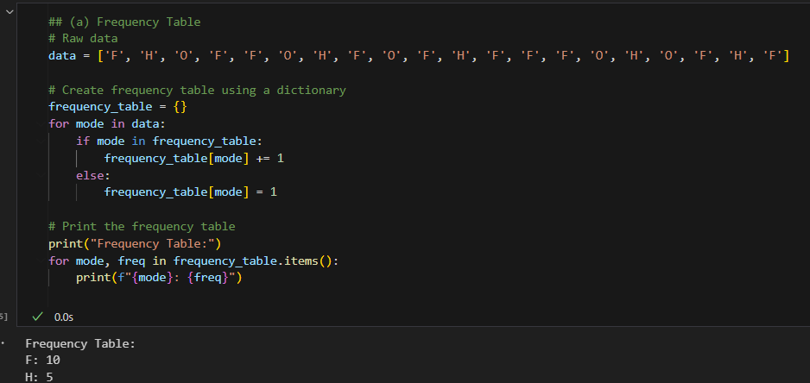
(b) Based on your table, create a Bar Chart to represent this data. Remember to label your axes and give the chart a title.
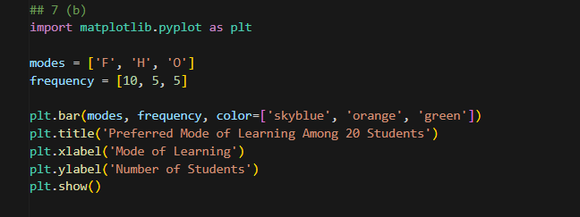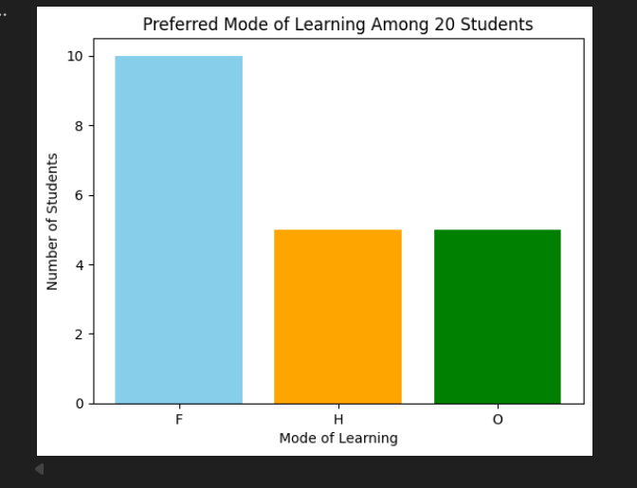
(c) Based on the chart, what is the most popular learning mode? What percentage of students prefer it? 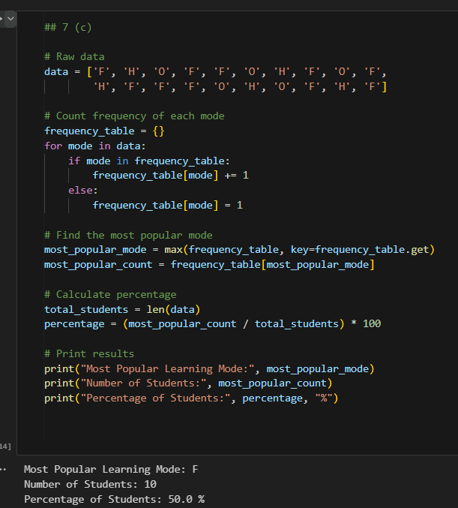

(d) Why is a Histogram not a suitable graph for this type of data?
Ans:
A histogram is used to represent numerical/continuous data that is divided into intervals (called bins).
Example: Exam scores, heights, weights.
Our data is categorical (F, H, O), not numbers.
Categories do not have a numeric order or range.
Using a histogram for categorical data doesn’t make sense because histograms rely on continuous intervals.
✅ Correct Graph for Categorical Data:
Bar Chart → height of each bar shows the frequency of each category.
Pie Chart → shows proportion of each category as part of a whole
## 7 d
import matplotlib.pyplot as plt
# Raw data
data = ['F', 'H', 'O', 'F', 'F', 'O', 'H', 'F', 'O', 'F',
'H', 'F', 'F', 'F', 'O', 'H', 'O', 'F', 'H', 'F']
# Count frequency of each category
frequency_table = {}
for mode in data:
if mode in frequency_table:
frequency_table[mode] += 1
else:
frequency_table[mode] = 1
# Prepare data for bar chart
modes = list(frequency_table.keys())
frequencies = list(frequency_table.values())
# Bar chart
plt.bar(modes, frequencies, color=['skyblue', 'orange', 'green'])
plt.title('Preferred Mode of Learning Among 20 Students')
plt.xlabel('Mode of Learning')
plt.ylabel('Number of Students')
plt.show()
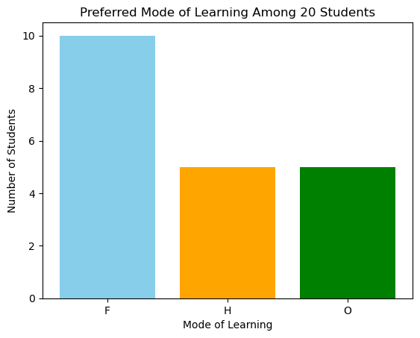

ASSIGNMENT 2
Q.1 A jar contains 5 red and 7 blue marbles. Two marbles are drawn randomly one after the other without replacement. What is the probability that the second marble is red, given that the first one was blue?
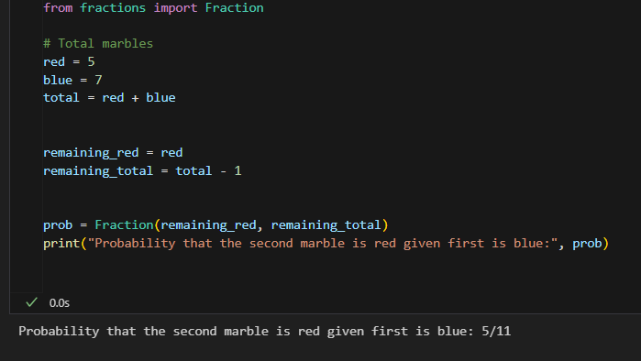

Q2. Suppose a laboratory test on a blood sample yields two possible results, positive or negative. According to the industry reports, the blood sample 95% of the people with a particular disease yield positive results. But 2% of the people without the disease also give positive results (false positive). 1% of the total population is infected by the disease. Determine the probability that a person chosen randomly from the population will have disease given that the blood sample of the person tests positive?

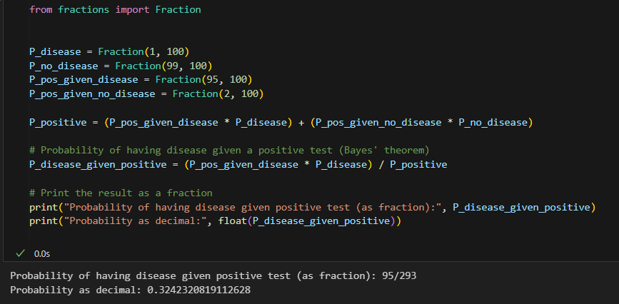

Q3. A patient from the population given above walks into the clinic of a doctor with some symptoms of the disease. After examining the patient and without checking the blood test report, the doctor gives his opinion that there are 30% chances that the patient is suffering from the disease. How should revise his opinion after checking the blood report
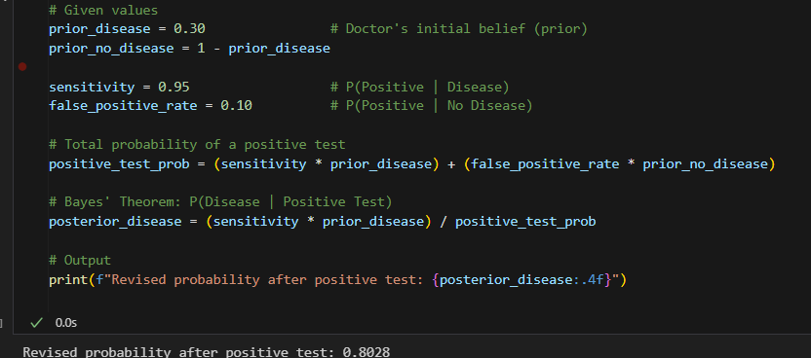

Q4. In a group of 50 students, 30 study Physics, 25 study Chemistry, and 15 study both. Draw a Venn diagram to represent this and find the probability that a randomly selected student studies only Physics.
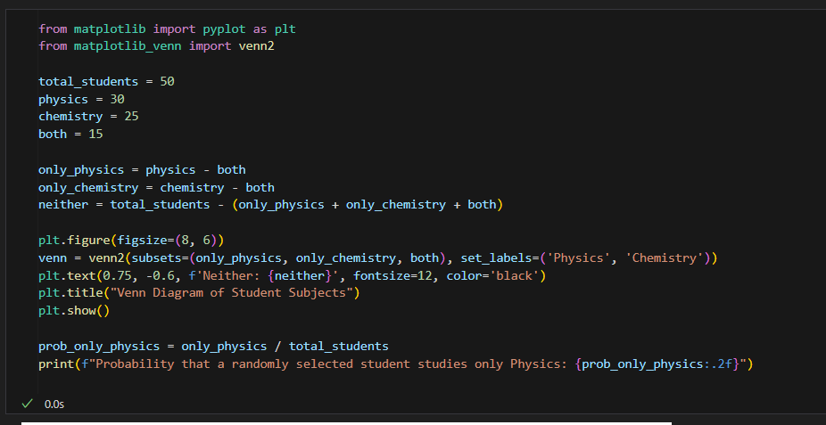

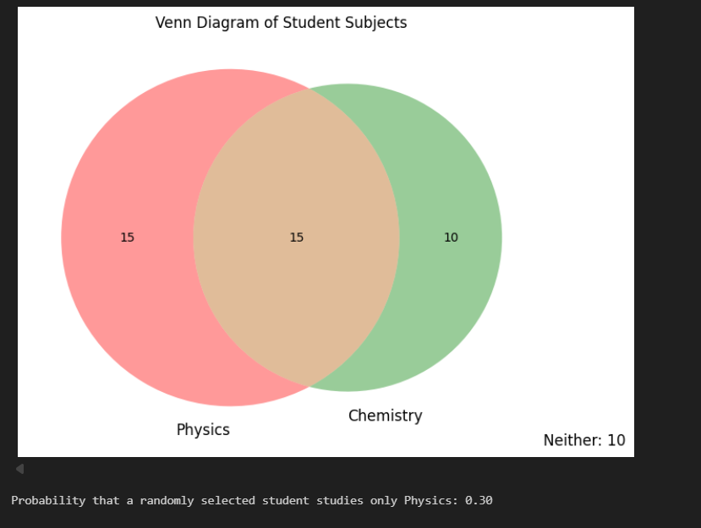
Q5. In a group of 50 students, 30 study Physics, 25 study Chemistry, and 15 study both. Draw a Venn diagram to represent this and find the probability that a randomly selected student studies only Physics.

